COMP718 2024
Tutorial: Governance and strategic planning for security
This tutorial comprises a review tasks (Task 1) and a problem-oriented exercise (Task 2).
Task 1. Controls, threats, vulnerabilities
You are a security consultant. You have been commissioned by a university that offers most of its programmes online, to help them develop their InfoSec programme. As part of your work, you are using the article below. You have found table 14, 15 and 16, and Figure 3 very helpful in understanding the risk environment in a typical higher education (HE) institution. Ulven, J. B., & Wangen, G. (2021). A Systematic Review of Cybersecurity Risks in Higher Education. Future Internet, 13(2), 39.
The authors have conducted a literature review and have analysed the causes and consequences of the threat events that are typical for HE institutions. For example, Figure 3 does not specify types of attacks and vulnerabilities to a specific typical threat and highlights the assets that are most likely to be affected.

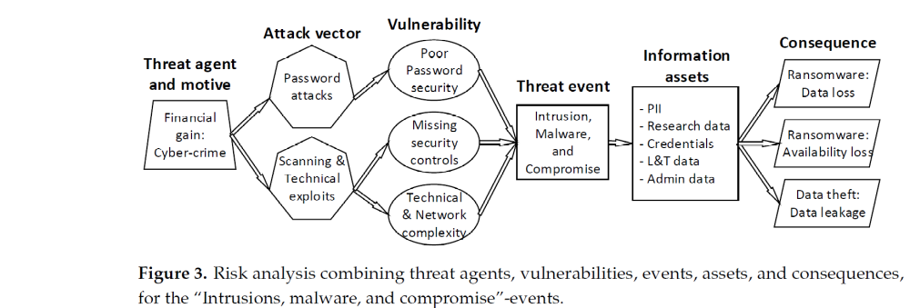
Therefore, you decide to use table 16 as a guide. It lists seven threat events. Two of them are DoD/DDoS attacks, and Abuse and Misuse incidents
Operational, technical and managerial security controls that would be appropriate for handling DoS/DDoS attacks.
According to the article, these are the vulnerabilities that enable Dos/DDoS attacks on IT assets, affecting their availability.
Incident | Vulnerability | Threat | Asset | Consequences
Managerial controls: Inefficient security management –-> can be addressed through managerial controls. Develop an InfoSec programme that will include the assessing the vulnerabilities of your asset and the associated risk, and managing these
Operational controls: Complexity cannot be changed but can be addressed by developing comprehensive plans of how to respond to the attack and how to recover from it. Consider outsourcing to the cloud
Technical controls: Missing security controls, resources and finance invest in design an up-to-date firewall protection. Remote work is a danger, consider VPN. Monitor traffic, obtain AI tools to identify attacks (IDS/IPS).

Suggest operational, technical and managerial security controls that would be appropriate for handling abuse and misuse incidents.

Managerial controls: develop an infosec programme, provide guidelines for policy development.
Operational controls:
- security culture particular attention to raisins security awareness and training. Different people – students, staff – may require different approaches. Posters for students? Training sessions for staff? Also, to who and how to report.
- Develop a policy about acceptable use of IT resources
Technical controls: means to stop and prevent?
Misuse: ‘the wrong or improper use of something’: using university computers for playing games (students). Controls: monitoring use?
Abuse: destruction, concealment, theft, or alteration of materials provided to assist students in the mastery of course materials. https://www.lawinsider.com/dictionary/abuse-of-resource-materials
Control: limit student access to ‘read’; limit staff access to what they need only

Task 2. Review the concept of planning and answer the following questions
What are the three common levels of planning? | Operational, tactical, strategic
What is a strategy? | Long-term direction, along with appropriate resource allocation
What is InfoSec governance? | The way senior management achieves secure use of the organisational resources and the security of the participants in the business processes

